MMT TUNC CENTER RESIDENCE / Alanya

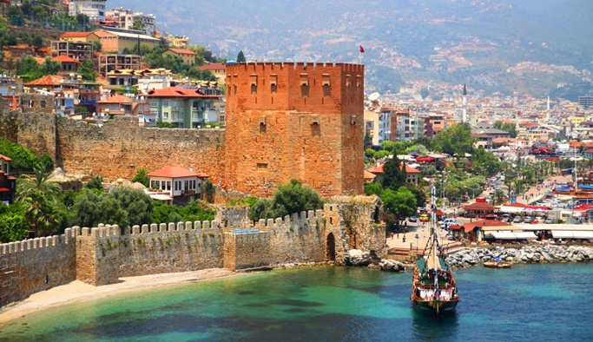 MMT TUNC CENTER RESIDENCE is being built on a total area of ​​1.127 m²

Our project MMT TUNC CENTER RESIDENCE is located in the center of Alanya, 100 meters from the sea. The famous Keykubat beach with golden sand and a developed network of beach clubs, bars and restaurants will be a pleasant addition to a comfortable life in our complex! In addition, our project is within walking distance of chain stores such as Migros, Carrefour, A101 and Bim.

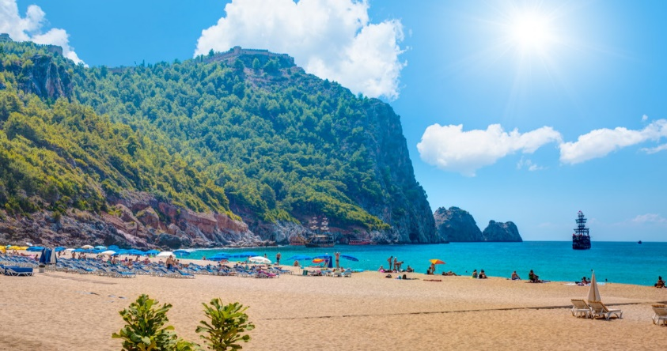 The infrastructure of the complex includes an outdoor swimming pool, fitness, parking, sauna, generator children's area. There will be 5 shops on the ground floor. Our professional team is ready to make a presentation for you and help you choose the perfect apartment!

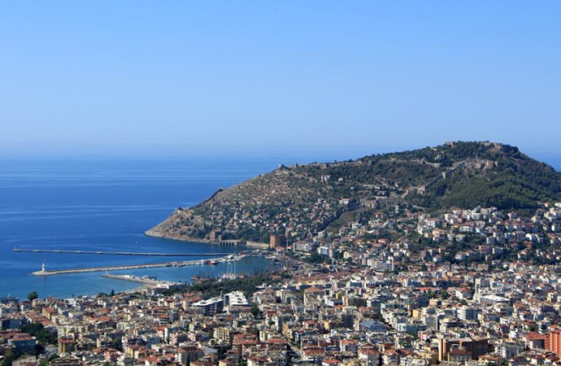 TOTAL 36 APARTMENTS

1+1: 12 PCS

2+1: 14 PCS

2+1 DUPLEX: 10 PCS.

INITIAL PAYMENT 40%, POSSIBILITY OF INSTALLATION FOR THE REMAINING AMOUNT BEFORE CONSTRUCTION COMPLETION.

CONSTRUCTION START DATE: 01/01/2023  
END DATE: 01/01/2024