UYAN GÖKSU / AVSALLAR

Avsallar is located on the road to Antalya Airport, 25 km from Alanya. Although there are enough urban opportunities for life in it, it became popular with its nature and pure oxygen. This is an ecologically clean area with the world famous Incekum beach. The freshest fruits, vegetables and natural products can be found in stores, as well as in markets open on certain days of the week. There are 5 hospitals and clinics, 7 pharmacies, 4 veterinary clinics and dental clinics in the center of Avsallar. There are also branches of international cargo companies in walking distance from our project. It is a very popular area for investment as well as for a quiet daily life in nature.

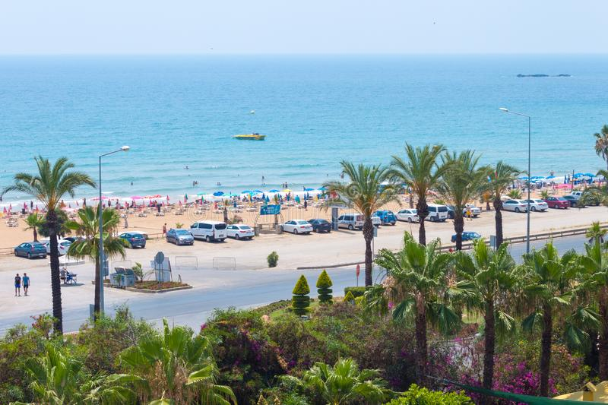 UYAN GÖKSU is built on a total area of ​​495 m² and promises you a healthy life surrounded by panoramic views of nature and plenty of pure oxygen. In order to have a good time, the complex has an outdoor swimming pool, gym.

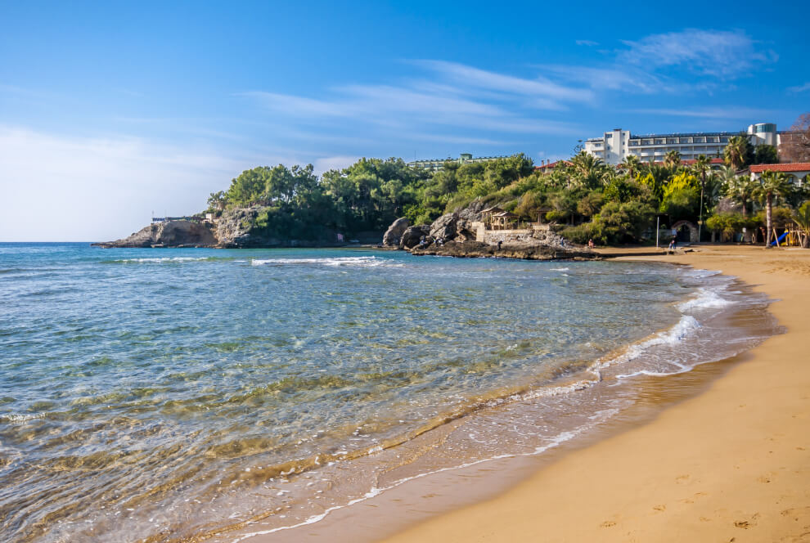Our project UYAN GÖKSU is located in Avsallar Center, 25 km from the center of Alanya and 400 m from beach. In addition, our project is within walking distance of chain stores such as Migros, Carrefour, A101 and Bim. We are ready to present you with our professional team and help you find the apartment of your dreams.

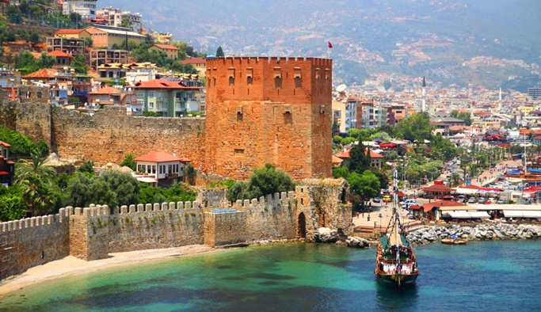

TOTAL 12 APARTMENTS

1+1: 9 PCS.

2+1 DUPLEX: 3 PCS.

INITIAL PAYMENT 40%, POSSIBILITY OF INSTALLATION FOR THE REMAINING AMOUNT BEFORE CONSTRUCTION COMPLETION.

START DATE: 08.08.2022

END DATE: 01/05/2023