EKB LUXURY / ÇIPLAKLI

ÇIPLAKLI is located two km from Alanya. It’s a well-developed neighborhood, with all the urban infrastructure, but it is mostly famous with its nature and pure oxygen. It is an ecologically clean area with the world famous beach of Cleopatra. The freshest fruits, vegetables and natural products can be found in stores, as well as in markets open on certain days of the week. In the center of Alanya there are 5 hospitals and polyclinics, 15 pharmacies, 8 veterinary clinics and dental clinics. There are also branches of international freight companies within walking distance of our project. It is a very popular area for investment, as well as for quiet everyday life in nature.

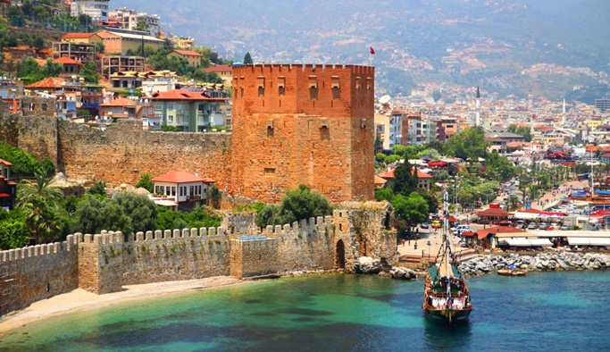EKB LUXURY is built on a total area of 950 m² and promises you a healthy life surrounded by panoramic views of nature and a lot of pure oxygen. In order to have a pleasant time, the complex has an outdoor swimming pool, sauna, generator gym, outdoor children’s playground.

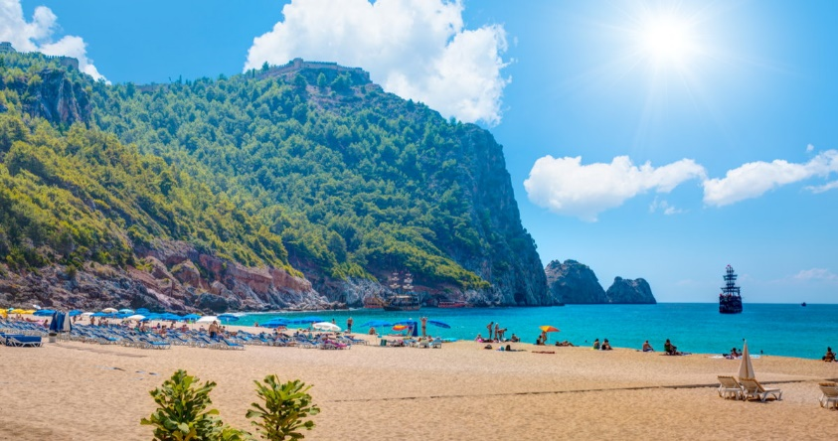

Our project EKB LUXURY is only 3 km from the center of Alanya and 2.5 km from the beach Cleopatra. In addition, our project is within walking distance of chain stores such as Migros, Carrefour, A101 and Bim. We are ready to give you a presentation and research with our professional team.

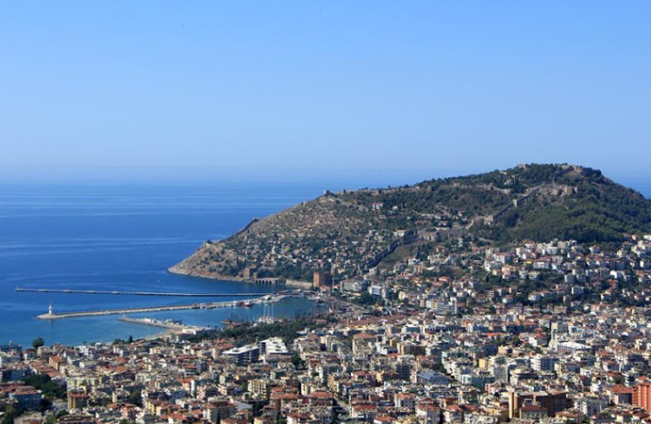TOTAL OF 16 APARTMENTS

1+1: 8 pcs.

2+1: 4 pcs.

2+1 DUPLEX: 2 PCS.

3+1 DUPLEX: 2 PCS.

INITIAL PAYMENT 40%, POSSIBILITY OF INSTALLMENTS FOR THE REMAINING AMOUNT UNTIL COMPLETION OF CONSTRUCTION.

CONSTRUCTION START DATE: 01.09.2022

DATE OF GRADUATION: 01.09.2023